SIMATS ENGINEERING — ASSESSMENT TOOL 2
COURSE NAME: Internet Programming | COURSE CODE: CSA4308
CO3 — TECHNICAL PRESENTATION : ANSWER KEY / SPEAKER NOTES
CO-3: Implement dynamic web applications by utilizing DOM-based client-side scripting and employing Java Servlets for server-side request processing and response handling. (L3)

Topic 1 — Servlet Architecture & Workflow
Present the architecture of Java Servlets and explain the complete request–response cycle with a neat diagram.
Focus areas covered: Client–Server interaction · Role of Web Container · Request and Response objects
Answer:
1. The big picture
A servlet-based application is a 3-tier system: the Client (browser), the Web Container (the servlet engine inside a server such as Apache Tomcat), and the Servlet itself (the Java class containing business logic), optionally backed by a Database. The Container is the crucial middle-man — the browser never invokes the servlet directly; it always goes through the container.
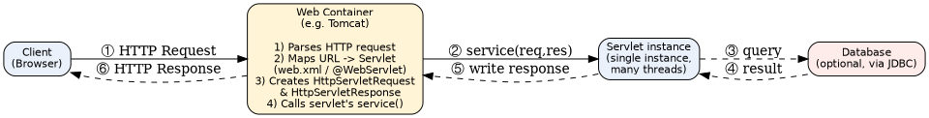
Servlet architecture and the request–response cycle
2. Client–Server interaction
The interaction follows the standard HTTP request–response model:
- The client (browser) opens a TCP connection and sends a plain-text HTTP request — a method (GET/POST/…), a URL, headers, and optionally a body — e.g. POST /RegisterServlet HTTP/1.1.
- The server (container) parses that request, routes it to the correct servlet, executes the servlet's logic, and sends back an HTTP response — a status line (200 OK, 404, 500…), headers, and a body (usually HTML/JSON).
- HTTP is stateless: the server treats every request independently unless a session-tracking mechanism (Question 4) is layered on top.
3. Role of the Web Container
The Web Container (e.g. Tomcat, Jetty) is what turns a plain Java class into a servlet that can serve HTTP requests. Its responsibilities include:
- Life-cycle management — loading the servlet class, creating a single instance, and calling init()/destroy() at the right times (see Question 2).
- URL mapping — deciding which servlet should handle an incoming URL, using either the deployment descriptor (web.xml) or the @WebServlet annotation.
- Object creation — constructing the HttpServletRequest and HttpServletResponse objects for every request and handing them to the servlet's service() method.
- Concurrency — running each request on its own thread from a pool, so one servlet instance can serve many simultaneous users without the overhead of a new process per request.
- Cross-cutting features — session management, security constraints, and (in Java EE) filters/listeners around the servlet.
4. Request and Response objects
These two container-supplied objects are the servlet's entire interface to the outside world — the servlet never touches raw sockets.
Object | Purpose | Commonly used methods
HttpServletRequest | Represents the incoming HTTP request; carries everything the client sent | getParameter(name), getHeader(name), getSession(), getInputStream(), getMethod(), getCookies()
HttpServletResponse | Represents the outgoing HTTP response; used to build what is sent back to the client | setContentType(type), getWriter(), addCookie(c), sendRedirect(url), setStatus(code)
5. The complete request–response cycle, step by step
- ① The browser sends an HTTP request to the server's URL for the servlet.
- ② The Web Container matches the URL to a servlet, creates the Request/Response objects, and calls service(req,res), which dispatches to doGet()/doPost() based on the HTTP method.
- ③–④ Inside the method, the servlet may query a database via JDBC to read/write data (optional, e.g. for the registration or product examples in AT1).
- ⑤ The servlet writes the result into the response object (HTML, JSON, a redirect, etc.).
- ⑥ The container converts the response object into a real HTTP response and sends it back over the same connection to the browser, which renders it.

Topic 2 — Servlet Life Cycle Analysis
Explain the Servlet Life Cycle with a sequence diagram and analyze the role of init(), service(), and destroy() methods.
Focus areas covered: Life cycle phases · Execution flow · Performance implications
Answer:
1. Life-cycle phases
Every servlet passes through five phases, managed entirely by the Web Container:
- Loading — the container loads the servlet's .class file into the JVM (usually on the first request that needs it, or at start-up if load-on-startup is configured).
- Instantiation — the container creates exactly ONE object of the servlet class (unlike, say, one object per request).
- Initialization — init(ServletConfig) is invoked once, immediately after instantiation.
- Ready / in-service — the servlet now handles requests via service(), for as long as the application runs.
- Destruction — destroy() is invoked once, and the instance is garbage-collected, typically when the application is undeployed or the server shuts down.
2. Sequence diagram — execution flow over time
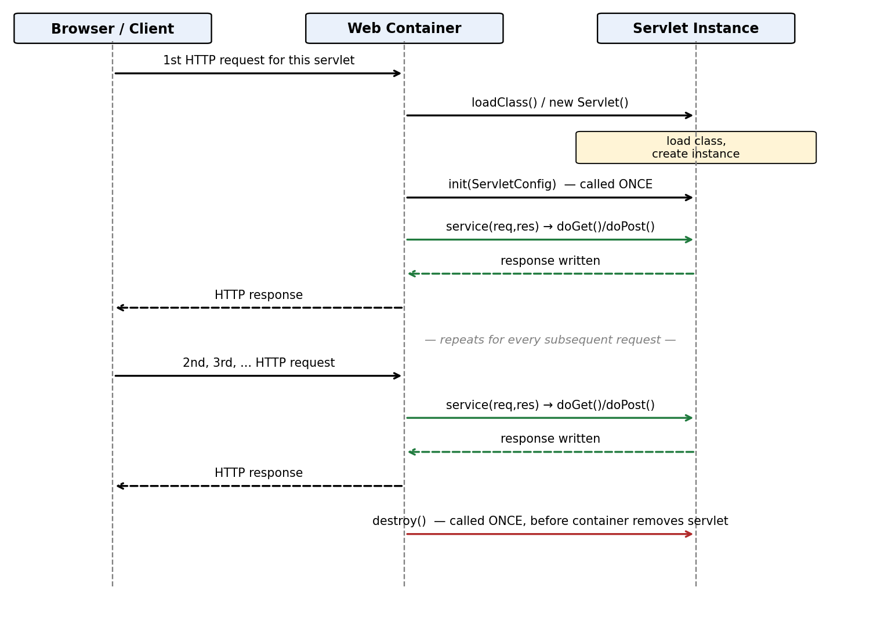
Sequence diagram: Browser ↔ Web Container ↔ Servlet Instance
Note how init() happens only once, at the very start, while service() (and the doGet()/doPost() it dispatches to) repeats for every single request that arrives afterward — and destroy() happens only once, right at the end.
3. Role analysis of each method
Method | Called | Role / responsibility | Analysis
init() | Once, before the servlet handles its first request | One-time setup — read init-parameters, open a database connection pool, load configuration or reference data | Because it runs only once, expensive setup work belongs here rather than in service() — doing it per-request would be wasteful and slow
service() | Once per request (delegates to doGet/doPost/doPut/doDelete) | Core request processing — read parameters, apply business logic, produce the response | This is the performance-critical path since it runs on every request; it must be fast, thread-safe, and free of heavy one-time setup
destroy() | Once, when the container retires the servlet | Clean-up — close DB connections/pools, flush caches, release file handles or threads started by the servlet | Skipping proper clean-up here causes resource leaks (e.g. unclosed DB connections) that degrade the server over its uptime
4. Performance implications
- Single instance, many threads: because only one servlet object is created and reused for every request (thread-per-request model), the container avoids the heavy cost of loading the class and re-running init() for every request — this is far faster than the old CGI model of spawning a new process per request.
- Thread-safety responsibility shifts to the developer: since many threads execute service() concurrently on the SAME instance, any instance (non-local) variables are shared state — unsynchronized mutable instance fields can cause race conditions; request-specific data should stay local to the method or be stored in the HttpServletRequest/HttpSession instead.
- Amortized initialization cost: init() overhead (e.g. opening a connection pool) is paid once and then amortized across potentially millions of requests, so it has almost no impact on steady-state throughput.
- load-on-startup: if configured, init() cost is shifted to server start-up rather than delaying the very first user's request — improving perceived latency for that first request at the cost of a slightly slower deployment/start-up.
- Resource leaks from a missing/incomplete destroy(): if connections or threads opened in init() are not released in destroy(), repeated redeploys (common in development) or server restarts gradually exhaust resources — a subtle but real performance/availability risk.

Topic 3 — GET vs POST Method Evaluation
Compare GET and POST methods used in form submission. Present scenarios where each method is appropriate.
Focus areas covered: Data transmission · Security aspects · URL limitations
Answer:
1. How each method transmits data
GET — parameters are appended to the URL as a query string:
GET /search?keyword=servlet&category=java HTTP/1.1
Host: example.com
POST — parameters travel inside the request body, separate from the URL:
POST /RegisterServlet HTTP/1.1
Host: example.com
Content-Type: application/x-www-form-urlencoded
Content-Length: 41
name=Raj&email=raj%40mail.com&password=secret123
2. Side-by-side comparison
Aspect | GET | POST
Data transmission | Appended to the URL as a query string | Sent inside the HTTP request body
Visibility | Visible in the address bar, browser history, and server access logs | Not shown in the URL; not written into typical access logs
URL length limitation | Practically capped (~2000 characters in most browsers/servers) — unsuitable for large forms | No inherent length limit — suitable for large forms, file uploads
Security | Poor for sensitive data — values are exposed in the URL, can be cached/bookmarked/shared accidentally | Better suited for sensitive data — but still needs HTTPS for actual encryption in transit
Idempotency / semantics | Meant to be safe & idempotent — repeating it should not change server state (good for reads) | Meant for state-changing operations — submitting, creating, updating data
Caching / bookmarking | Can be cached by browsers/proxies and bookmarked | Not cached or bookmarked by default
Back-button / resubmission | Refreshing/going back simply re-fetches the same URL, harmlessly | Refreshing/going back can trigger a 'resubmit form?' warning since it would repeat a state change
3. Scenarios where each is appropriate
- Use GET for: search boxes and filters (?q=servlet), pagination (?page=2), sorting, navigating between pages, viewing a specific record by ID — i.e. any read-only action a user should be able to bookmark, share, or refresh safely.
- Use POST for: login forms, registration forms, changing a password, submitting payment details, uploading files, adding items to a cart, or any action that creates/updates/deletes data on the server — precisely the RegisterServlet scenario from AT1's Question 1, where student data and a password are being submitted.

Topic 4 — Session Tracking Techniques
Present different session tracking mechanisms (HttpSession, Cookies, URL rewriting). Evaluate their advantages and limitations.
Focus areas covered: Session persistence · Security concerns · Use-case comparison
Answer:
1. Why session tracking exists
HTTP is stateless, so without extra help the server cannot tell that two requests came from 'the same user'. All three mechanisms below solve this by attaching some identifying token to every request from the same client; they differ only in WHERE that token is carried.
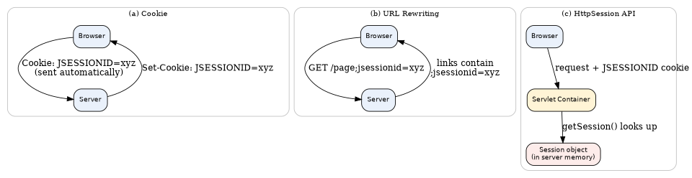
Three session-tracking mechanisms
2. Evaluation of each mechanism
Mechanism | How it works | Advantages | Limitations
Cookies | Server sends Set-Cookie: JSESSIONID=xyz once; browser automatically resends it on every later request to that domain | Simple, automatic, works across many pages without any code change; can persist across browser restarts if given a max-age | Depends on the browser accepting cookies; vulnerable to theft via XSS if not marked HttpOnly/Secure; users can clear/block them
URL rewriting | Session ID is appended to every link/form action as a URL parameter, e.g. ;jsessionid=xyz | Works even when cookies are completely disabled — a reliable fallback | Session ID appears in the URL — can leak via browser history, bookmarks, shared links, and the Referer header sent to third-party sites; every link on every page must be rewritten
HttpSession API | High-level servlet API; container stores the actual data server-side and only ships an opaque ID to the client (via cookie, or URL rewriting as fallback) | Actual data never leaves the server — safest option; supports rich Java objects, not just strings; automatic timeout handling | Consumes server memory per active user; in a clustered deployment needs session replication or a shared store; still relies on cookies/URL-rewriting just to carry the ID
3. Session persistence
- Cookie-based tracking can persist beyond the browser session if given a max-age (e.g. 'remember me' for 7 days); HttpSession itself normally ends when the browser is closed unless the underlying cookie is made persistent.
- URL rewriting only persists for as long as the user keeps clicking rewritten links — copying a bare URL without the jsessionid loses the session.
- HttpSession has a configurable inactivity timeout (setMaxInactiveInterval()) independent of how the ID is carried — the session dies server-side after inactivity even if the client still has the cookie.
4. Security concerns
- Cookies: susceptible to cross-site scripting (XSS) if a malicious script can read document.cookie — mitigated with the HttpOnly flag; susceptible to interception on unencrypted connections — mitigated with the Secure flag (cookie sent only over HTTPS).
- URL rewriting: the session ID becomes part of the URL, so it is the least secure option — it can be logged by proxies/servers, cached, or leaked to external sites via the Referer header.
- HttpSession: the data itself is safe on the server, but the session is only as secure as the ID that identifies it — if that ID (usually via cookie) is stolen, the attacker can hijack the session (session fixation/hijacking), so IDs should be regenerated on login and sessions invalidated on logout.
5. Use-case comparison
- Cookies alone — good for low-stakes, long-lived preferences: theme choice, 'remember my username', analytics ID.
- URL rewriting — a fallback path built into the container for the rare visitor who has disabled cookies; rarely chosen deliberately by developers today.
- HttpSession — the default choice for anything involving authentication or meaningful application state: logged-in user, shopping cart contents, multi-step form wizards, CSRF tokens.

Topic 5 — Cookies vs Sessions: Critical Analysis
Analyze and compare Cookies and Sessions in web applications. Present real-time use cases.
Focus areas covered: Storage location · Security risks · Performance considerations
Answer:
1. Core distinction
A Cookie is a small piece of data stored entirely on the CLIENT and echoed back on every request. A Session (via HttpSession) stores the actual data on the SERVER, and uses a cookie (or URL rewriting) merely to carry an opaque session ID — the client never sees the real data. This one difference drives almost every other trade-off below.
2. Detailed comparison
Dimension | Cookie | Session (HttpSession)
Storage location | Client-side (in the browser) | Server-side (in the web container's memory, or a shared store in a cluster)
Data exposed to client | Yes — the actual value is stored/visible on the client and can be inspected/edited by the user | No — the client only holds an opaque session ID; real data stays server-side
Capacity | Small — roughly 4 KB per cookie, limited number per domain | Effectively bound only by server memory — can hold whole Java objects (a User, a Cart, etc.)
Security risk | Value can be read/tampered with by the user or stolen via XSS if not HttpOnly/Secure; must never hold raw sensitive data (e.g. plaintext passwords) | Safer for sensitive data since it never leaves the server, but vulnerable to session hijacking if the session ID itself is stolen, or session fixation if the ID is not regenerated on login
Performance considerations | Adds a little size to every HTTP request/response (sent with every call); no server memory used, so it scales trivially with user count | Consumes server RAM per active user — many concurrent sessions can pressure memory; in a load-balanced cluster, needs sticky sessions or session replication, adding infrastructure complexity/latency
Lifetime control | Developer sets an explicit max-age; can outlive the browser session | Developer sets an inactivity timeout; container also cleans up on browser close (if the carrying cookie is non-persistent) or explicit invalidate()
3. Real-time use cases
- E-commerce cart for a guest user: often kept as a Cookie (or a session backed by a temporary guest ID) so the cart survives even without login — but once the user logs in, the cart is typically moved into the server-side Session/DB tied to their account.
- Online banking login: MUST use server-side Session, never a cookie holding account data — the cookie should carry nothing but an opaque, short-lived, HttpOnly+Secure session ID, with a short inactivity timeout for security.
- 'Remember me' on a login page: implemented with a long-lived Cookie storing a random persistent-login token (never the password), separate from the short-lived login Session — a classic real-world hybrid of both mechanisms.
- Personalization (language, currency, theme): a simple long-lived Cookie is enough — low security stakes, no need to burden server memory with a Session for it.
- Multi-step checkout/registration wizard: kept in the Session so partially entered data (address, payment step) is available across pages without exposing it in cookies or the URL.
4. Critical takeaway
In practice, well-designed applications use BOTH together, each for what it is good at: Cookies for lightweight, client-owned, low-risk data (and to physically carry the session ID itself), and Sessions for anything that must remain confidential or that is too large/structured to fit in a cookie. Treating them as interchangeable is a common source of real-world security bugs — e.g. storing a user's role or authentication flag directly in a plain cookie, which a user could edit to escalate their own privileges.
Code of Conduct:

I K. Sai Kumar(192372080)(Name / Reg No) certify that this submission is my original work and that I have adhered to the guidelines specified for this assessment. I understand that any violation of academic integrity rules will result in disciplinary action.

Signature of the student:
RUBRICS FOR CALCULATION:

Technical Presentation
Criteria | Weight age | Level 4 – Exemplary | Level 3 – Proficient | Level 2 – Developing | Level 1 – Beginning
Technical Content Accuracy | 30 | Highly accurate, in-depth, and insightful technical  explanation | Technically correct content with adequate depth and  clarity | Basic concepts presented with limited accuracy and depth | Content contains major technical errors; concepts poorly  understood
Problem Identification | 25 | Problem rigorously analyzed using appropriate and advanced  methods | Problem clearly defined with a logical engineering approach | Problem identified but analysis or methodology is weak | Problem statement unclear or incorrect; no logical  approach
Use of Tools | 20 | Advanced tools, well-analyzed data, and highly effective visuals | Appropriate tools and data used effectively with clear visuals | Limited use of tools and basic data interpretation | Minimal or incorrect use of tools and data; poor visuals
Communication | 15 | Highly engaging, confident, and audience-focused delivery | Clear, organized, and professional communicatio n | Understandable but lacks clarity, structure, or confidence | Poor organization, unclear speech, ineffective slides
Professionalis m | 10 | Exemplary professionalism, leadership, and ethical awareness | Professional conduct with effective team collaboration | Basic professionalism; uneven team participation | Lacks professionalism  ; minimal contribution or ethical  awareness

